
11 July 2014 The Weekly Bulletin of Rotary Club of Kathmandu Mid-Town bc-02/7.014
Rotary Club of Kathmandu Mid-Town
Breakfast Chatter


District: 3292 Web: www.rotarymidtown.org.np Club Id: 26776

JULY 2014

Celebrating
25 Years in Rotary


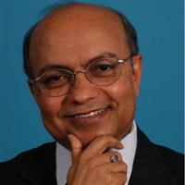
Rtn Kul C Gautam takes over Club Presidency
with effect from First July 2014.
Congratulations!
President’s message:
2014-15 marks the Silver Jubilee of the Rotary Club of Kathmandu Mid-Town. In its 25 years, it has acquired the reputation of being a highly cosmopolitan club with a high profile, well-known for its diverse membership and many community service projects. Building on its glorious history, we hope to contribute to the RI’s goal to Light Up Rotary in this landmark year of our club. We also hope to inspire the younger generation to engage in community service through our network of Rotaract and Interact members. We will strive to cultivate a stronger sense of solidarity among our members and society at large, to make a modest but meaningful contribution to Nepal’s development and global peace.

Friday, 4 July : The first meeting of the year 2014-15
President Kul C Gautam started the meeting with introductory remarks, welcomed everyone present in the meeting and thanked members as well as Board for offering to serve as the Club President in 2014-15. He also noted that he was conducting Rotary meeting without wearing the Rotary collar as the installation ceremony was yet to take place. He thanked IPP Saroj for his good work during the previous Rotary year.
Tour de table – Pres Kul Chandra asked each member to recount briefly their happiest, most memorable positive moment in their association with Rotary. Members and guests present recounted their happy/memorable moments in Rotary.
Sharing information:
- The Installation Ceremony is scheduled on 11 July 2014 at 18:00 hrs at Hotel Soaltee.
- President Kul suggested that Mid-Towners become familiar with RI's 'My Rotary' and that Club files and Minutes would also be available on the Mid-Town web page. Rotary throughout the world is going 'paperless'.
- All members to note that club membership fee (Rs 30,000) need to be paid by end of this month, that is, July.
- Senior members whose age plus years in Rotary equals 85 or above are requested to fill out an 'excused absences' form which will entitle them to automatically receive LOA without requesting it each time.
- President Kul requested members on the occasion of the Club's 25th anniversary to renew their commitment to Rotary by becoming second level PHFs.
- IPP Saroj informed that 25 sets of a commemorative book from the District Conference 2010-11 (complete with paintings by Nepali artists) were made available. These would be handed out to members who attended the Conference.

Weekly Meetings and Programs :
Date | Program/Speaker | Program/Topics of Presentation
11 Jul 2014 | 25th Installation of the Club | At Hotel Soaltee
18 Jul 2014
25 Jul 2014

Friday, 11 July :
25th Installation of the Club
Rtn Kul C Gautam is going to be installed as President for the year 2014-15.
Venue: Soaltee Hotel; Program starts at 18:30 hrs.
Installation dinner follows after the meeting.
The dinner is free for members. Guests/spouses pay Rs 2,000 each.
All club-members are invited; please do come and attend this special occasion with family members and friends.

Know your President:
Rtn. Kul Chandra Gautam is a distinguished international civil servant, development professional, public policy expert, and human rights activist. Previously he was Deputy Executive Director of UNICEF and Assistant Secretary-General of the United Nations. He has extensive experience in international diplomacy, development cooperation and humanitarian assistance.
Currently, Mr. Gautam informally advises Nepal’s senior political and civil society leadership on the peace process, consolidation of democracy and socio-economic development. He also serves on the Boards of a number of international and national foundations, charitable organizations and public private partnerships. Along with other prominent Nepali citizens, he led a Rollback Violence Campaign in 2008-2010. In 2010-11 he served as Special Advisor to the Prime Minister of Nepal on International Affairs and the Peace Process.
In his long and distinguished career with the United Nations, spanning over three decades, he had extensive dealings with leaders of governments, donor agencies, multi-lateral organizations, NGOs and the corporate sector in policy dialogue, advocacy and resource mobilization.
As a senior UNICEF official, Kul Gautam provided leadership for strategic planning, policy guidance and programme management. He coordinated inter-agency collaboration and public-private partnerships for child rights and human development among UN agencies, donors and civil society organizations.
At the global level, Kul dealt with the highest levels of policy making at the United Nations, including the General Assembly, Security Council, ECOSOC and the UNICEF Executive Board. And he oversaw UNICEF cooperation in over 150 developing countries.
Kul Gautam was the highest-ranking Nepali in the UN system. During the decade-long civil war, he worked hard informally to secure the support of the UN and other key players to promote peace and reconciliation in Nepal. He spoke forcefully against violence, impunity and violation of human rights by all parties in the conflict. He continues to speak out and write extensively on the peace process, democracy, human rights and post-conflict reconstruction and development in Nepal.
Born in a small village of Gulmi district in Nepal, Kul Gautam received his higher education in international relations and development economics at Dartmouth College and Princeton University in the United States of America. He is married and is blessed with two children - a daughter and a son.
Kul has been recently named as one of the global leaders for education by Global Partnership for Education (GPE), a multilateral agency devoted to quality education in the world’s poorest countries. He is among a select group of prominent world leaders such as former UN Secretary General Kofi Annan, former British Prime Minister Gordon Brown and American economist Jeffery Sachs to help the GPE in its noble effort.
Chaired by former Australian Prime Minister Julia Gillard, the GPE relies on prominent advocates who are committed to raise the profile of education in the global development agenda. Initially founded in 2002 as “Fast Track Initiative for Education for All” and hosted by the World Bank, this initiative has up to 2012 made a total disbursement of around US $ 2 billion for basic education in some of the world’s poorest countries, including Nepal.
Source: www.kulgautam.org

I hope many of you will choose to host a Rotary Day, to show your community what Rotary is
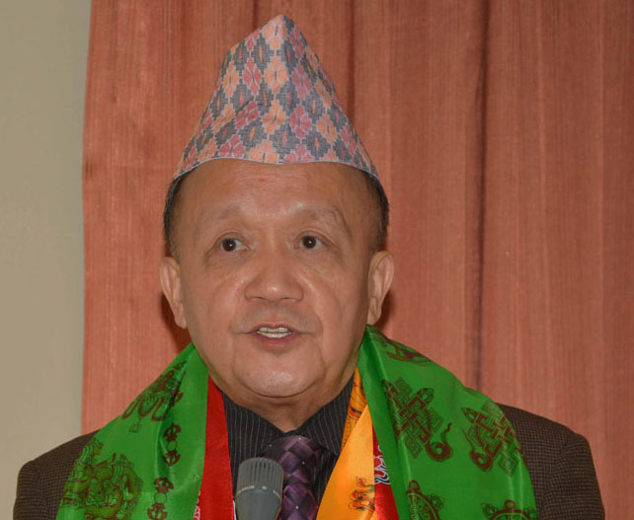
and what we do. I hope you will involve your Rotaract and Interact clubs in your service, to
bring the new generation of the Rotary family closer to Rotary membership. And I hope you will
keep Rotary strong by inviting new members into Rotary – including your own spouse and
family.

RI President GARY C.K. HUANG

Please send information on club activities, progress reviews on service projects, relevant photos etc to:
BC Editor: RR Shrestha email: rryesrr@gmail.com

11 July 2014 The Weekly Bulletin of Rotary Club of Kathmandu Mid-Town bc-02/7.014

